The core design elements for Quest: To Be Defined

Quest: To Be Defined Design Document

By James Moran

Contents

Elevator Pitch 2

Story 2

Characters 3

User Interface and Game Controls 3

Main menu 3

New Game 4

Credits 4

Main Menu UMG Widget Version 1.0.0 4

Top-Level 4

Level/Environment Design 4

Sample View upon Starting First Level 6

Player Movement System 6

Gameplay 7

How PIBot behaves in the first level 7

The CombatAdmin 7

The Brick Weapon 8

Weapon Pick up Confirmation 8

Weapon Ammo HUD Element 9

Armour HUD Element 9

Carrying Mass HUD Element 9

Weapon Statistics System 9

Sacramento’s Introduction 10

The Tutorial Enemy and the Combat Tutorial/Dialog Tutorial 10

Sacramento’s AI 11

Sacramento’s Movement Animations 11

Second Section of the Introduction Level 11

Private Matterson 12

# Elevator Pitch

A Third-Person shooter, in which the player has statistics related to their health and armour, is able to obtain items such as weapons and armour, follows linear routes through a level to complete an objective and they will also meet certain characters along their route that can help or hinder them. The aforementioned features are tied together by a story, which grants context to the actions the Player is taking, as well as the respective consequences of these actions.

# Story

At the mid-point (absolute), of the twenty-second century, you are walking along a canyon path. The canyon is layered in evenly cut grass (interesting…), with the sides too steep to scale, so indeed; you keep walking along, until you come across a decline in the canyon path, where you notice a metal mass that seems to equate to a deactivated robot, but without even a moment to observe this construct; it comes to life, with a pleasant and enthusiastic greeting:

(Note: That there are multiple dialog options for the Player to choose in game, which will effect the story. To provide the story for this section; I have chosen one specific route.)

“Greetings unknown person! I Think I must have been falling asleep here, waiting for someone like you to walk down the road and notice me!”

“I am PIBot, that is; ‘Personal Intelligence’ robot.”

“I say falling asleep, but I don’t mean really, I am a robot after all…but I can imitate sleep, must have done so while I was being bored, waiting.”

“Guess I must have been left here after the war of Twenty-One, ah well.”

“As such, I have something of the upmost importance to say, but first; what is your name? Do tell me…”

You tell PIBot that your name is…”Unknown”.

“’Unknown’ eh? …Very well, I shall hence forth, refer to you as unknown then, hmm…the unknown person, not too interesting…”

“Ok then, I’ll follow you! Let us go down the road a bit, as I have something to tell you, don’t want anyone sneaking up on us you see so down the road a bit, then I’ll tell you.”

So our group as it were; you and PIBot, walk along the path a fair distance, to ensure that they could procure the necessary degree of privacy.

When PIBot believed that they had put suitable distance between them, from where PIBot had awakened to your presence, they were ready to tell you what they knew…“Right, the thing I need to tell you is tha-” …all of a sudden though, looking upwards; both them and you could see an interesting flying contraption…“Greetings team that requires my help and assistance! I am the CombatAdmin. I administrate combat, as well as a few other tasks, in addition to combat administrating.”

“Good to know, other robot that appeared out of nowhere.”

“Regardless, I must tell you what I know, or we could be in trouble, what I need to tell you, is tha-”

…although PIBot has tried to tell the Player what they know once again (after the CombatAdmin interrupted this information outlet by PIBot), they get interrupted again…“Ah, there you are, I am the one, the only, Sacramento! Ha-ha! Tell me, where are you off to then?”

Even though you are surprised that this person appeared out of nowhere, you respond fairly quickly with: “Nowhere in particular.”

Sacramento then asks you: “Good…then you won’t mind staying here now, will you?”

An interesting question, as given its negative implication, you respond with “Yes”; as you would not mind staying put. As this is the case; Sacramento tells you of their plan: “Ah...I have a plan to inform you of then, you see, I have scouted out what is up ahead, I have seen a bunch of military grunts out there, I will assist you with them, by using this ground to ground missile I have here: *Shows the missile to the player* I just require a target location of your choosing, I also have a shotgun on me, to blast them with, let’s get started then.”

So now; Sacramento has joined your group as well, after warning you and PIBot of what you can expect up ahead.

Banking left along the canyon path, you and your group see a sub-segment of the canyon path to the left of the main canyon path (after already turning left once), which then prompts Sacramento to recall a certain snippet of info…“Wait up there, just here *Points at the canyon sub-segment* is where I left a certain item. I think we should collect that.”

So our team heads into this part of the canyon, off to the left of the main canyon path. Only a few seconds after heading into this segment of the canyon, Sacramento catches sight of the aforementioned item…“Ah, there it is, my beloved speciality grenade, hmm…although I was going to look for this item earlier, I believe it would make sense if you took it.” “Very well then.” You say to Sacramento, taking his speciality grenade from him, as he hands it to you.

Getting back onto the main canyon path, 75 metres further down the path, our team notices that the canyon path is getting narrower and not only that; there is a minor incline in the canyon, noticeable, but not too hard for our team to scale up. Upon the group members’ (including yourself) minor alteration to their current altitude, you notice 2 seemingly useful items; a machine-pistol and some body armour. “I think those are decent items to make use of…hold on, what is your name?” says Sacramento to you and so, you feel as though it would make sense to equip these items. Whilst getting yourself ready with this equipment; you mention to Sacramento that “My name is Unknown, by all means, I also think it would make sense to use these items”.

Our team carries on along this narrower, raised, branch of the canyon path for about 9 metres longer, before seeing this branch expand outwards, into a much wider clearing for this canyon. Moving further ahead, you and the rest of the team take cover behind a slope, not too far into where the canyon opens up.

Glancing for a brief moment over the top of the slope, you see 6 people wearing soldier uniforms, grouped together and currently idle, 1 of them keeping a lookout along the entrance to this wider canyon segment. Even looking over the top, they still seem to have not noticed you or any other members of the team (including the CombatAdmin for some reason), hiding back behind the slope again, out of sight of these soldiers, you ask Sacramento “So who are they?” “Ah, those are the bunch of military grunts I told you about earlier. Oh, in order for my plan to work, I have connected to that CombatAdmin’s video feed, to lock onto their location, to fire a missile from the launcher I showed you earlier, without them seeing us.” “I thought CombatAdmin had become unusually quiet…” remarked PIBot. “Ah don’t worry, this CombatAdmin of yours is fine, I just wanted to get line of sight to those grunts, in an incognito way”. “So long as the CombatAdmin is ok…”.

With the CombatAdmin’s assistance, Sacramento follows through with their plan: “Fire in ze hole…” he whispers quietly. And indeed, a missile is released from his launcher. With the missile heading straight up, at approximately 500 metres; the missile plunges towards the target location and at this point in the missile’s trajectory (before impact), the grunts are alerted to the presence of an enemy, drawing their weapons and charging towards your group, hiding behind the slope.

Peaking over the top once again, you notice that this is case. As bullets fly over the top of your head, you decide that it is sensible to take cover once again. You urgently ask Sacramento “So what now in this plan of yours!?”, with Sacramento simply (and calmly), stating that “Well, I will guide ze missile towards them, distract them please.”.

So you quickly crawl over to the left of where the rest of the group is hiding, with your machine pistol at the ready, with the intent to peek out and fire a few shots in their general direction (to distract them from the impending missile impact). Looking over the top once again, you take aim and fire 1 shot (pulling the trigger back for a millisecond and then releasing, to not discharge more than one round), but unfortunately, this simply glances off the soldier grunt’s helmet (that you were aiming at). As fast as lighting, they are alerted to your presence at this point in the slope now, not only altering their path of fire, but also their velocity, so that this particular soldier is now moving towards your location.

Ducking behind the slope for but a moment to think again about how to use your weapon, you peek out once more, but this time; pining the trigger, which causes the weapon to discharge multiple shots, without a moment’s notice between each shot. Luckily; this causes the soldier charging directly at you, to fall, crying out from the rounds impacting them (so they are still alive), but no longer charging at you.

This time, the other soldiers are alerted to your presence as well, altering their direction, so that they are charging towards you and so; more bullets whizz past and over you.

“How long now?!!” you shout towards Sacramento. “Sooner than you might think…”. This is absolutely the case; as not even a second later, the missile impacts the ground near these soldier grunts, dismembering them as though their armour matters not.

You and the rest of the group cease handing, rising to stand and see how successful Sacramento’s plan turned out.

Indeed, all bar one of the soldiers have vanished, with the one grunt, lying face up on the ground, with no signs of life in them.

“Of course my plan worked, z’ehy had not even known what hit z’ehm.” Stated Sacramento, feeling accomplished. “Well that is most useful to know Sacramento, I had no worries at all.” Said PIBot in response, quite delightfully. “So now what?” you ask the group. “Well, I believe that plan resulted in success.” Was the response given by the CombatAdmin. “And I can detect no more enemies nearby.”. “Let’s carry on, zehn…” “Yes, continue onwards we shall and will.” Mentioned PIBot (after Sacramento’s piece).

So you and the group continue onwards and upwards, in what would soon become an adventure, most worthy of note.

# Characters

## The Player

The Player Character, is indeed, a character in the game and also the pawn that the Player will control, with a distressing past that they wish to get away from, they are wandering about the world and have come across this canyon path, which they follow to begin the story.

## PIBot

PIBot (the ‘Personal Intelligence Robot’), is met by the Player, when they start walking along the canyon path, for the first level. With important information to tell the Player, they will follow the Player, as they move along the canyon trail, attempting to inform the Player of what they know, at various points on this trail.

## CombatAdmin

The CombatAdmin (a flying robot), appears at one of these points on the canyon trail, following the Player and PIBot along, as they follow this trail, with the intent to administrate any combat that occurs…and not much else.

## Sacramento

Soon after the CombatAdmin appears, PIBot attempts to inform the Player of their important knowledge, but is once again interrupted, this time though, by Sacramento. He is presumably a human, with French origins (given his accent). It appears that they intended to come upon the Player Character, teleporting in to their location for when the Player will first encounter them. He has an interesting character to him and also, he can become the Player’s ally, or enemy…

## Pvt. Matterson

There are 6 of them in the first level, that the Player will encounter towards the end. These are the ‘military grunts’ that Sacramento will mention, if the Player wants to hear Sacramento’s plan. Even if the Player would not want to hear Sacramento’s plan earlier, they will still have to deal with these soldiers. They are clones (all instances of the original Pvt. Matterson), with simply a number appended to the end of ‘Pvt. Matterson’, to uniquely identify each soldier (Pvt. Matterson1, Pvt. Matterson2 etc.).

# Level/Environment Design

The layout of the first level is currently what is shown below:

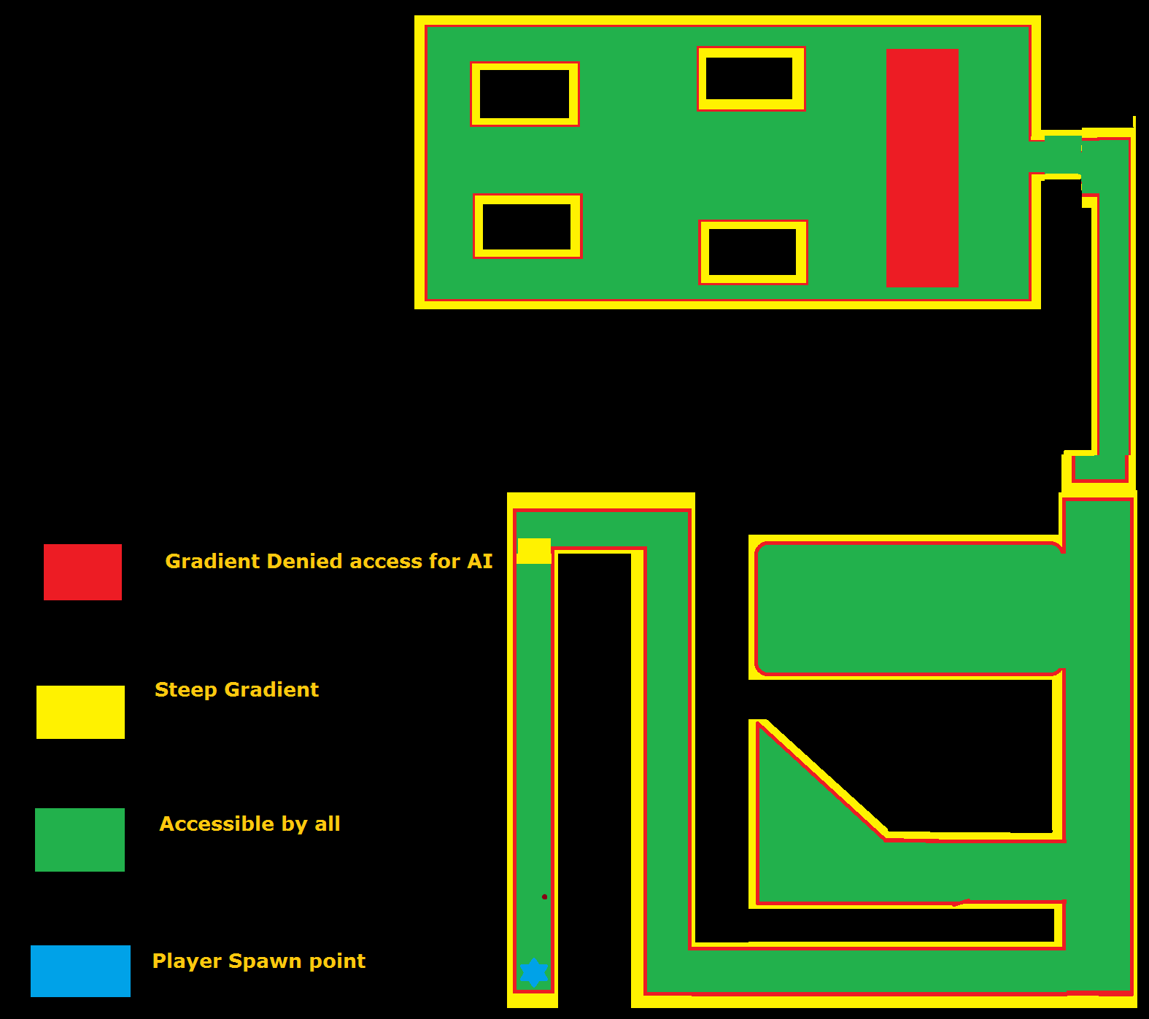

Where black indicates areas that the player cannot get too and are at least 2 times higher than the player model.

# User Interface and Game Controls

## Main menu

The main menu is a UMG (Unreal Material Graphic) Widget, the mouse cursor is shown to the player, so that they can use this GUI (Graphical User Interface), which shows five buttons upon being created and added to the viewport, these are:

* New Game
* Load Game
* Options
* Credits
* Exit

### New Game

At the moment, this contains one button, the start button, this will start the game by opening the first level.

#### Start

Pressing on this button will stream load, open the first level and spawn the player at the first level’s starting spawn point, this level is called QTBDIntro, mostly a linear canyon, which the player must follow.

### Credits

Pressing this button, will display the credits for the game.

### Main Menu UMG Widget Version 1.0.0

### Top-Level

Red indicates the start of the incline up to the top of the peaks, where it starts getting harder for the player to move up them.

Yellow indicates where the incline is starting to increase steadily, to the point where the player can get no higher.

Green indicates where the player can move in the level, even over certain obstacles and through other elements of the level.

The blue star is where the player spawns into the level, to end the level, they have to complete an objective.

Finally, the maroon dot; indicates where there is a target dummy, which the player can damage and even destroy if they so wish.

## Sample View upon Starting First Level

### Player Movement System

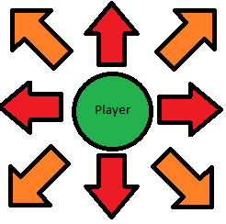

The player can move along the X and Y axis, either positively or negatively, to go forwards, backwards, to the left and to the right, with W, S, A and D respectively, in addition, they can combine movement along both of these axes, simultaneously, to more in another 4 directions, forwards and to the left, forwards and to the right, backwards and to the left, backwards and to the right.

This can be represented by the following diagram, where the player is at the centre of the arrows, showing the 8 possible directions they can move in:

Where the red arrows, show directions that can be moved in by pressing one of the 4 movement keys (W, A, S or D), while the orange arrows, showing the other 4 directions that can be moved in with a combination of 2 movement keys (WA, WD, SA or SD).

They can change their movement speed in any and all directions with the left and right Alt keys, left to increase the % of base they go at, right to decrease that % of base speed. Currently +/- 0.01 (1%) of their base speed (1.00, 100%). The animation for moving in any of the 8 directions changes according to their move speed, from running at full pace, to walk, to shuffling, they can also sprint for a 1.75 times multiplier of their current speed, regardless of what % of base speed it is at. The bindings are Left-Alt for plus movement speed, Right-Alt for minus movement speed, if Ctrl is held down before pressing left alt, it will increase the player’s speed by 10%, not just 1%, while if Right-Ctrl plus Alt is pressed, it will decrease the player’s speed by 10%, not just 1%.

Note that the player’s speed, will be a factor in accuracy while shooting.

# Gameplay

### How PIBot behaves in the first level

As described in the section above, PIBot will start off in the first level, on the ground, deactivated. When the player gets close enough (as determined by PIBot’s Proximity Detection Sphere), PIBot will play the death animation that made PIBot appear deactivated, in reverse, so PIBot will appear to jump up, then after an intro sequence, will follow the player around, always attempting to be within 50 units of the player.

PIBot uses a Nav. Mesh to follow the player around, this Nav. Mesh is as big as the whole level, allowing PIBot to find the player, even if PIBot does not have line of sight to the player.

PIBot uses a duplicate of the player’s Skeletal Mesh, with a grey metal coloured material painted onto it, as well as using all of the player’s animations, with a copy of their Animation Blueprint, as their Skeletal Mesh is a duplicate of the one the player uses (replace with a mesh, that is similar to a standard Galactic Ranger, from Ratchet and Clank 3, GET A REFERENCE IMAGE FOR SUCH).

The player can just leave PIBot to jump up and begin their intro, without being held back, but PIBot will cut themselves short when the player gets to a certain point, in the path ahead, then shout; “Hey, wait up!” (or another similar phrase), and run after them (at an increased speed, so that they can catch up to the player?). The player is stopped after causing the trigger to fire, but PIBot does not move to them, they are also stopped if they enter the volume again, fix this, so PIBot does shout something at them, they are stopped only once and are also told to enter their name, before moving on.

### The CombatAdmin

When the player enters the second crevice of the canyon, at a certain point, the CombatAdmin will fly in and give its introduction, similar to PIBot, the player can keep going, then the CombatAdmin will complain about being interrupted by the player, PIBot will also respond to the Com Ad complaining.

The CombatAdmin will not use a Skeletal Mesh (for now), just a few primitive shapes, for a construction; with a similar build to that of certain current age drones (such as a Predator Drone), even though the CombatAdmin is not a drone though, but it is a robot, like PIBot, so is completely automatous.

### The Brick Weapon

The first weapon the player can get, is a brick, which they can throw at enemies and pick it up again if they so wish. I have yet to determine whether to let them keep onto the brick, or for it to be removed from their inventory, upon completing the first level.

The brick will cause ~10 points of damage to be done to enemies, twice that of unarmed combat (resolve issues with unarmed combat) and so; not too much more, but the brick is a ranged projectile weapon, so they do not have to get as close to enemies, in order to engage combat with them. A radial impulse component provides the force and impulse to the brick, when it is thrown.

The BrickWeapon is a sub-class of QTBDWeapon, which in of itself, is a sub-class of QTBDItem.

## Weapon Pick up Confirmation

When a weapon is picked up by the player, a message telling them what weapon was picked up will be displayed to them for five seconds (display a screenshot of this, change this for any item that has been picked up too, whether it is a weapon or not).

## Weapon Ammo HUD Element

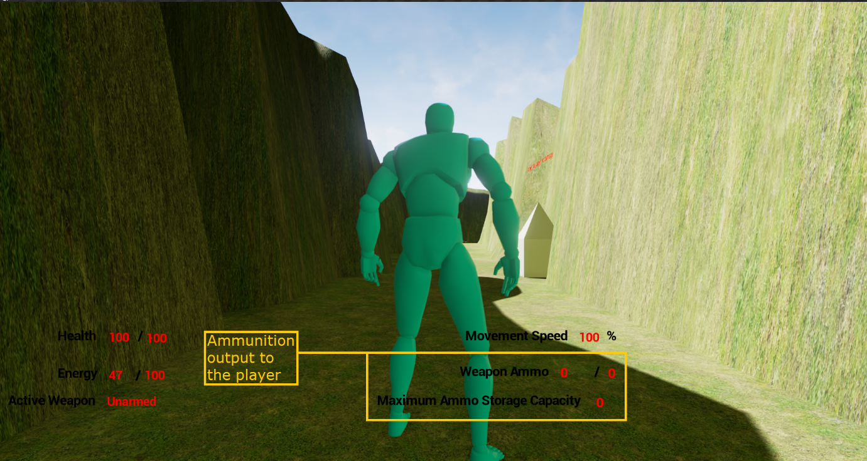

(The above screenshot shows this element of the player’s HUD, highlighted in a yellow box, with a caption to the left)

This text, shows how much ammo is left in that weapon’s total storage capacity, out of its maximum ammo, for weapons that have ammunition, there will always be an initial starting quantity of ammo, for melee weapons, this will be ‘0’, in addition, the loading mechanism’s (whether it is a clip, magazine etc.) storage capacity will also be shown, once again, being ‘0’ for melee weapons.

## Armour HUD Element

The player’s current active armour, plus the damage resistance of said armour, is shown on the HUD, here: (Add a screenshot to show such soon)

## Carrying Mass HUD Element

The player’s current carrying mass, as well as their maximum carrying mass, is shown on the HUD, here: (Add a screenshot to show such)

## Weapon Statistics System

There is a class, which all weapons have as a member, which stores the various stats of that weapon, such as its damage, how much ammo it has, uses per loading mech. Etc. This is used instead of spawning objects, say, above the player’s head, for getting the statistics of a given weapon, such as the BrickWeapon, while the BrickWeapon actor is spawned in a hidden location, this is the case for BrickWeapon, for unarmed, it is an actor without a mesh of any type, so it is hidden away near the spawn point for QTBDIntro.

## Sacramento’s Introduction

Before the combat tutorial begins (if it ever does), Sacramento will give their introduction, the control flow and final result for this is shown in this document, as the player can give many combinations of answers to Sacramento’s questions:..\SacramentoDialogQAASessionControlFlow.pub

## The Tutorial Enemy and the Combat Tutorial/Dialog Tutorial

This enemy also uses a copy of the same skeletal mesh and animation blueprint, as the player character and PIBot.

The combat tutorial/dialog tutorial will occur, after PIBot is trying to give the player advice, in either one of two possible routes, then Sacramento will appear and give their introduction.

The player will be put into Cinematic mode at this point in the level, so that Sacramento can give their intro, PIBot will say some dialog towards the player after Sacramento gives their first section of introduction dialog, then will teleport hide out of sight.

Sacramento will be spawned in a section of the canyon, outside the player’s line of sight, but then, will teleport near the player and give their introduction, putting the player in cinematic mode.

In either case, the player can then make various choices, which can affect the combat tutorial in some manor (even causing Sacramento to join their side, so there will not be one), depending on the choices the player makes, Sacramento will either attack the player or side with the player. The player can also begin combat early if they so wish, Sacramento will be frustrated at such though. Sacramento’s introduction can also be interrupted as well, which will cause them to become hostile, only saying part of their second introduction dialog section lines before attacking the player if they get interrupted.

Sacramento has a Prototype Shotgun for their primary weapon, they also have a grenade hidden near where they spawn, before teleporting, which if the player finds, can be used against Sacramento.

If the player has BrickWeapon, it will deal bonus damage against Sacramento, if the player finds and uses Sacramento’s hidden grenade and misses Sacramento, Sacramento will throw an insult their way, if the player hits Sacramento, if Sacramento is hit by the full force of the explosion (for maximum damage, thus, if the grenade explodes within 1,1,1 or so, of Sacramento), Sacramento will teleport away (possibly fighting the player again later on in the level?) and the tutorial will be over.

The Grenade has an explosion particle effect sequence and a sound, for when it explodes, it will kill whichever character is in the blast radius of the time of the grenade exploding, the grenade will be primed to explode upon being thrown, then will explode after approximately 5 seconds have elapsed in game.

### Sacramento’s AI

The logic of Sacramento’s behaviour tree is detailed in this document: ..\SacramentosAIBehaviorTreeBlueprint.pub

## Sacramento’s Movement Animations

Sacramento has the same animations for moving, jumping and dying as the player, but has additional animations for drawing his shotgun from his back, firing that shotgun, reloading it, as well as moving without firing it and moving while firing or reloading, as can be seen in this video presentation:

..\..\Videos\Games Dev. Videos\Quest; To Be Defined; Sacramento Animation Sample.mp4

### 

### Second Section of the Introduction Level

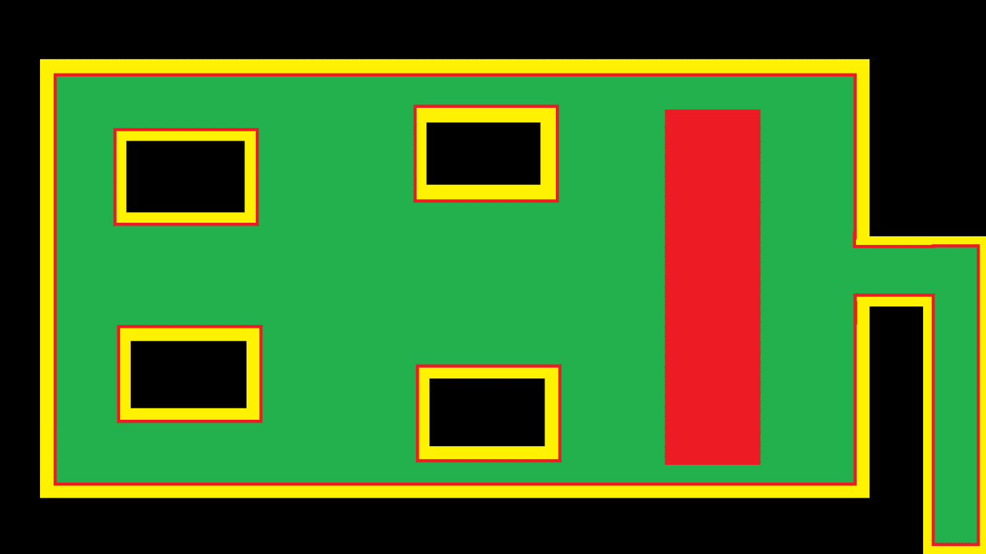After having their encounter with Sacramento, the player can now freely move into the second section of the canyon, with a planned layout of such:

Where Black indicates where the player cannot reach, yellow where the gradient gets steeper and steeper, to the point the player will be able to go no higher, red, where there is a traversable, but notably gradient and green where it is flat and the player can move around freely.

In this section, there will be a six of instances of the first NPC, which will always be hostile towards the player, Private Matterson.

### Private Matterson

When the player gets near to where the squad of multiple instances of Private Matterson is, the player will not be attacked by them straight away and can hear them having a light chat while the player and/or Sacramento do not reveal themselves.

Private Matterson has a cheap rifle (represented by the assault rifle from the prototype weapons pack), poor body armour and 100 hit points. Whenever any instance of Pvt. Matterson has the player in their line of sight, as well as them being close enough to that particular instance, they will look at the player, as well as notifying the other instances that they have seen a target and they should look in that direction as well.

Upon turning to face their target, they will draw their weapon and either start shooting, or heading to the location they were most recently looking at, then checking to see if they have line of sight once again, they will keep repeating this cycle until they can see their target, or their target has been eliminated.

They will also inform other instances that are nearby, that they have spotted a target nearby, which will cause the other instances to look in that area, also, if they have a target but line of sight is blocked by another instance of Pvt. Matterson, they will move to the left or right, to regain a line of sight to their current target.